201533661 이승수’s lab

**[lab 1-1]**

#include <stdio.h>

struct People

{

char name[10];

int age;

} person[5],oldest,youngest;

void main()

{

int i;

for (i = 0; i < 5; i++)

{

printf("person[%d]'s name:",i);

gets(person[i].name);

printf("person's age:");

scanf("%d", &person[i].age);

getchar();

if (i == 0)

oldest = person[0];

if (person[i].age > oldest.age)

oldest = person[i];

else

continue;

}

youngest = person[0];

for (i = 0; i < 5;i++)

{

if (youngest.age>person[i].age)

youngest = person[i];

else

continue;

}

printf("oldest:%s(%d), youngest:%s(%d)", oldest.name, oldest.age,youngest.name, youngest.age);

getchar();

getchar();

}

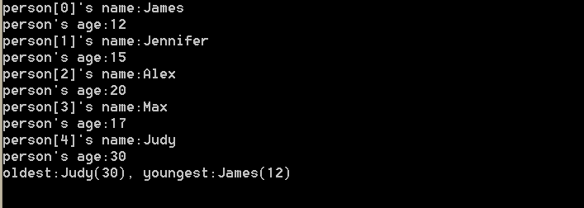

**[lab 1-2]**

#include <stdio.h>

struct CarInfo

{

char Model[10];

int Year;

}car;

struct information

{

char Name[10];

int Age;

struct CarInfo Car;

int CarNum;

}info;

void main()

{

int i;

printf("How many cars?");

scanf("%d", &info.CarNum);

getchar();

printf("\nName:");

gets(info.Name);

printf("\nage:");

scanf("%d", &info.Age);

getchar();

if (info.CarNum != 0)

{

printf("\n Car Model:");

gets(info.Car.Model);

printf("\n Car year:");

scanf("%d", &info.Car.Year);

}

else

printf("No car!!");

printf("\nName:%s, Age:%d, CarNum:%d", info.Name, info.Age, info.CarNum);

for (i = 0; i < info.CarNum; i++)

{

if (i != 0)

{

printf("\n%d.Car Model:",i);

gets(info.Car.Model);

getchar();

printf("\n%d.Car year:",i);

getchar();

scanf("%d", &info.Car.Year);

}

printf("------------------\nCarnumber:%d \nCarModel:%s \nCarYear:%d ", i, info.Car.Model, info.Car.Year);

}

}

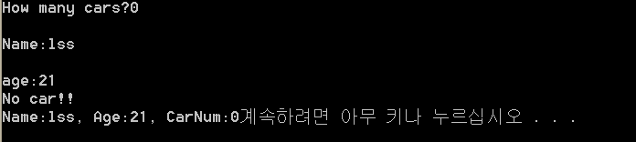

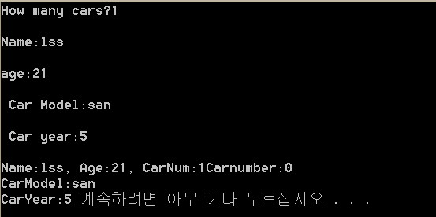

**[lab 1-3]**

#include <stdio.h>

struct CLASS

{

char Name[20];

int NumCredit;

char Grade;

}class[5];

void GradeTranslate(char *Grade)

{

switch (*Grade)

{

case 'A':

*Grade = 4.0;

break;

case 'B':

*Grade = 3.0;

break;

case 'C':

*Grade = 2.0;

break;

case 'D':

*Grade = 1.0;

break;

case 'F':

*Grade = 0.0;

break;

}

}

float GPA(int classnum, struct CLASS *class)

{

int i;

float GPA, SUM = 0, creditsum = 0;

for (i = 0; i < classnum; i++)

{

printf("(%d)\ngets class name:", i);

gets((class[i]).Name);

printf("gets class credit:");

scanf("%d", (class[i]).NumCredit);

getchar();

printf("gets class grade:");

scanf("%c", (class[i]).Grade);

GradeTranslate((class[i]).Grade);

}

for (i = 0; i < classnum; i++)

{

SUM += (class[i]).Grade*(class[i]).NumCredit;

creditsum += (class[i]).NumCredit;

}

GPA = SUM / creditsum;

return(GPA);

}

void main()

{

int Classnum, i;

printf("Add ClassNum:");

scanf("%d", &Classnum);

getchar();

printf("GPA:%f", GPA(Classnum, class));

}

